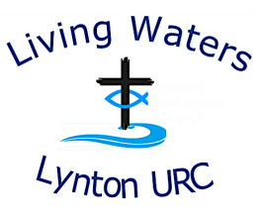
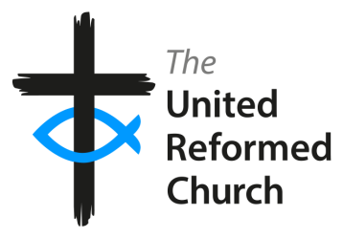
Living Waters Lynton United Reformed Church

Risk Assessment Template – Events Away From Church Premises

PLEASE ADAPT WITH INFORMATION ON INDIVIDUAL VENUES AS REQUIRED

Event | Events away from church premises  Home groups, eg Bible study and Alpha, pastoral visiting, public spaces and other premises, eg village halls  Please complete  Please complete  Please complete  January 2026  January 2027
Type of Event
Location
Contact Details
Phone
Email
Date Completed
Review Date
Activity | Possible Risk | Prevention | Action to Reduce Risk | Responsibility | Deadline
Arrival – new visitors | Low  People unfamiliar with site layout and emergency/ fire procedures | A designated person will explain the layout of the building and explain what to do in case of emergency.  Information also to be given about rooms that are off limits, and position of toilets. | Arrange for someone at each event to be responsible for explaining the layout and emergency procedures | Event organisers
Safeguarding | Medium  Historical and current Safeguarding issues which might impact on individuals participating in church activities | Remind that the group should stay together at all times and that individuals and couples should not be alone behind closed doors together.  Know as much as possible who the adults at risk are, and assess their needs to ensure that activities are appropriate and safe.  Put into place any special measures required for people at risk  Ensure that Pastoral Team/Safeguarding Co-ordinator are aware of activities so that they can assess potentially unsafe situations based on ongoing and historical Safeguarding situations | Be aware of Safeguarding guidelines through training  Understand and regularly review hazards including equipment and resources  All volunteers to be trained in safeguarding and DBS checked if likely to come into contact with young people and/or adults at risk.  Leaders to be DBS checked and to have carried out Safeguarding training.  Safeguarding policy available in Lynton URC hirers handbook  Proactive intervention as and when required | Elders, Pastoral Team and Safeguarding Coordinator, event organisers | Ongoing for all church activities and events
Health & Safety | Medium  Tripping or slipping and causing injury | Health & Safety policy and risk assessment reviewed yearly.  Check for possible trip hazards  Request bags to be in safe place e.g placed under chairs | Attention drawn to all participants of its whereabouts (in folder held by organiser) | Events organisers, volunteers
Risk of Fire | Low | Emergency escape routes to be explained |  | Event Organisers,  volunteers
Refreshments  If only drinks and biscuits provided | Low  Allergies  Food poisoning | If a meal is provided then person providing and cooking the meal to be trained in food safety and allergens.  Food and ingredients information available  Ingredients listed and sell by date checked | The kitchen is maintained to good food hygiene standards  No training necessary – employ common sense | Event organisers,  anyone involved in the preparation of food  All
During the activities | Low  Theft of possessions  Someone is taken ill | Ensure that all attendees are responsible for their personal possessions  Have understanding of basics of medical emergency – choking, anaphylactic shock, position of defibrillators | Have access to a fully equipped first aid box that is checked 6 monthly. | Event organisers, volunteers, participants  As above
Sanitary | Medium  Possibility of infection |  | Ensure toilets clean and ensure supply of soap and paper towels available at all times | Events organiser, volunteers

