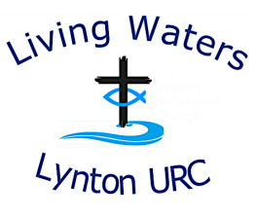
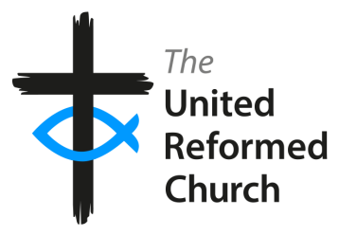
Living Waters Lynton United Reformed Church

Social Events/Visitors on Site Risk Assessment

Event | Social Events at Church  Various – Coffee Morning, Games Evening, Soup & Sweet, Carols & Mince Pies, Afternoon Tea, Shared Lunch, Refreshments after services  Church Hall, Lee Road, Lynton EX35 6BS  Julia Dolan, Church Secretary  07941 412186  livingwaterslynton@gmail.com/juliadolan@live.co.uk  January 2026  January 2027
Type of Event
Location
Contact Details
Phone
Email
Date Completed
Review Date
Activity | Possible Risk | Prevention | Action to Reduce Risk | Responsibility
Arrival – new visitors | Low  People unfamiliar with site layout and emergency/ fire procedures | A Church member will explain the layout of the building and point out the emergency/ fire procedures which are clearly displayed on the notice board | Arrange for someone at each event to be responsible for explaining the layout and emergency procedures | Event organiser
Safeguarding | Medium  Children who may attend: suitability of seating, food provided and hazards (eg small parts), obstacles, appropriateness of resources such as toys and literature, safety of equipment etc.  Adults at risk - identification, special needs, eg mobility, allergies, health (mental and physical)  Historical and ongoing Safeguarding issues which might impact on individuals participating in church activities | Ensure areas, equipment and resources used by children are appropriate and safe. Toys to be in good condition with any moving parts working properly, avoidance of choking hazards, chairs and tables maintained to a safe standard. Food hygiene rules to be observed, including consideration of allergies.  Know as much as possible who the adults and children at risk are, and assess their needs to ensure that church activities are appropriate and safe.  Put into place any special measures required for adults and children at risk  Ensure that Pastoral Team/Safeguarding Co-ordinator are aware of activities so that they can assess potentially unsafe situations based on ongoing and historical Safeguarding situations | Be aware of Safeguarding guidelines through training  Understand and regularly review hazards including equipment and resources  Ensure food hygiene and safety training is up-to-date and renewed every three years  All volunteers to be trained in safeguarding and DBS checked if likely to come into contact with children and/or adults at risk  Safeguarding policy available in Hall hirers handbook  Safeguarding contacts poster on noticeboard  Proactive intervention as and when required | Elders, Pastoral Team and Safeguarding Coordinator, event organisers | Ongoing for all church activities and events
Health & Safety | Medium  Tripping or slipping and causing injury  Injuries caused by handling furniture, eg weight of chairs and folding tables | Health & Safety policy and risk assessment reviewed yearly.  Floor coverings anti-slip  Chairs and tables only to be moved by designated people in charge of events | Attention drawn to all members of its whereabouts (in hirers’ handbook and on website)  Floor coverings checked regularly  First Aid box to be readily available and fully stocked in kitchen  List of First Aiders displayed on notice board  Chairs and tables only to be moved for specific purposes and only by those who have physical strength and dexterity to do so | Leadership Team  The organiser of the event  All volunteer helpers
Risk of Fire | Low | Fire doors in place and Fire/ Emergency procedures clearly visible on notice board.  Fire exits clearly marked and access clear.  Members to be aware of Fire Risk Assessment and to have knowledge of procedures for evacuation. | Members to be reminded of policies and procedures for evacuating the church in an emergency. | Leadership Team  Event Organisers  Volunteers and other Church Members
Refreshments | Low  Allergies  Food poisoning | One person trained in food safety and allergies attends each event  Kitchen staff trained to a competent level  Food ingredients available/ listed  Notices explaining who to approach are displayed along with other certification  Clear notices that people are to wait to be served | Two church members are trained in food safety and allergies  The kitchen is maintained to official food hygiene standards  The social events checklist is used on every occasion to ensure standards are maintained  Notices obvious so that serving of food is only carried out by those in charge | Church Leadership Team  Event organisers  Kitchen staff  Attendees
During the activities | Low  Theft of possessions  Someone is taken ill | Ensure that all attendees are responsible for their personal possessions | List of First Aiders on notice board and First Aid box in kitchen kept up-to-date | All volunteers/members present  First Aiders
Sanitary | Medium  Possibility of infection | Hand sanitisers and face masks available at all entrances and in toilets | Ensure hand sanitisers are full and that there are enough face masks  Keep toilets clean and ensure supply of soap, paper towels and sanitiser available at all times | All volunteers/members present  The housekeeping team | 